READING AND QUESTIONS: TERRESTRIAL BIOMES

COMPONENTS OF THE BIOSPHERE: The biosphere is a narrow zone where organisms can live; it includes the waters of the earth, a small fraction of the earth's crust, and the lower region of air that surrounds the earth. The rocks, soils and sediments in which organisms live is called the lithosphere. Liquid and frozen water on or near the surface of the lithosphere is known as the hydrosphere, which includes the oceans and smaller bodies of water, the polar ice caps, and a small amount of water which is in the air. Surrounding the earth is a region of gases, dust and other particles, and water vapor called the atmosphere. Therefore, the biosphere is made up of three parts: lithosphere, hydrosphere and atmosphere.

An ecosystem is defined as all the populations of different organisms within a given area and the physical environment that they occupy. The biosphere is composed of ecosystems, ranging in size from vast forests and stretches of tundra to small systems that occur, for example, in a pond. The distribution of different ecosystems is determined in large part by the earth's climatic system.

GLOBAL PATTERNS OF CLIMATE: What determines whether a particular region will be a desert, forest, cold sea or coral reef? The main determinant is climate. The word refers to prevailing weather conditions including temperature, humidity, wind velocity and direction, degree of cloud cover, and rainfall (although temperature and rainfall are probably the most important factors in determining the climate of an area). Climate itself is a result of many interacting factors including (1) differences in the amount of incoming solar radiation, (2) the earth's daily rotation and its yearly path around the sun, (3) the distribution of continents and oceans, and (4) the elevation of land masses.

Seasonal Variations in Climate: What causes seasonal variations in climate? Take a look at figure 1. The circle of light that divides the earth into days and nights is always perpendicular to the sun. However, the earth's axis is tilted in relation to its annual path around the sun. In December, the North Pole is most tilted away from the sun. Therefore, December in the Northern Hemisphere means winter; temperatures are lower than at other times of the year because days are shorter. Not so in the Southern Hemisphere, where December means summer; temperatures are higher because days are longer and light rays are not as spread out. The situation is reversed for the two hemispheres in June.

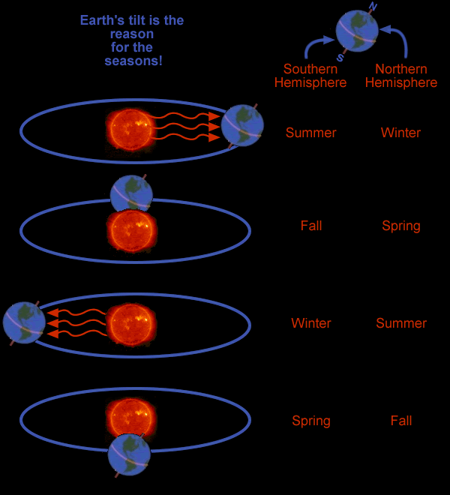

Figure 1. Annual variation in the amount of incoming solar radiation. Because Earth's axis is tilted at about 23° to the plane of its orbit about the sun, the amount of solar radiation reaching any point of Earth's surface varies during the year.
Regional Climates: Climate is influenced by more than general patterns of light, temperature and rainfall. It is influenced also by the presence or absence of bodies of water, mountains, valleys and vegetation cover.
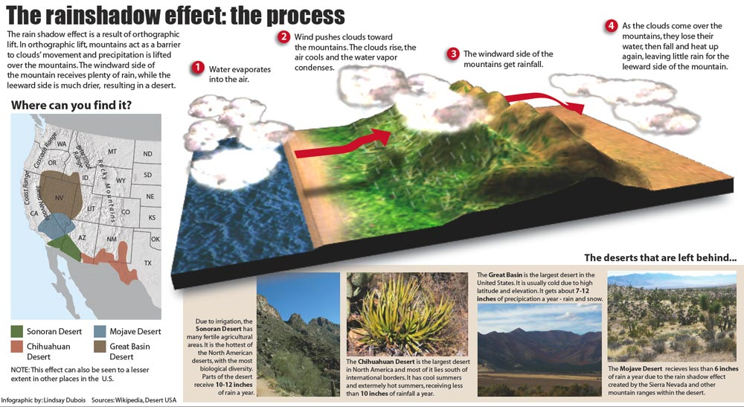
For example, many (but not all) deserts were formed because of high mountains. When prevailing winds reach a mountain range, the air rises, cools and loses moisture (cool air holds less moisture than does warm air). The general flow of weather across the US is from west to east. In the western US, there are several large mountain chains. Moist air moving eastward from the Pacific Ocean must rise up and over the mountains. Take a look at figure 2. As the air rises, it cools and loses the water it is carrying. The waters falls as precipitation (rain or snow) on the westward slopes. By the time the air crosses the mountains, it has very little moisture left. As it goes down the eastern side, the air warms up and its moisture-holding ability increases. This air draws moisture out of the plants and soil (evaporation) rather than giving it up as rain. Thus, a rain shadow exists on the leeward side of mountains, where the lack of abundant rainfall creates arid conditions. ("Leeward" means the direction facing the wind; "windward" means the direction from which the wind is blowing.)
Figure 2. The rain shadow effect of the western mountains of the US produces the deserts of the Southwest.

THE WORLD'S BIOMES: Large areas with similar climate and soil that support certain kinds of plants and animals are called biomes. Biomes include different types of deserts, grasslands, forests and tundra. The following is a discussion of the six major biomes of America.

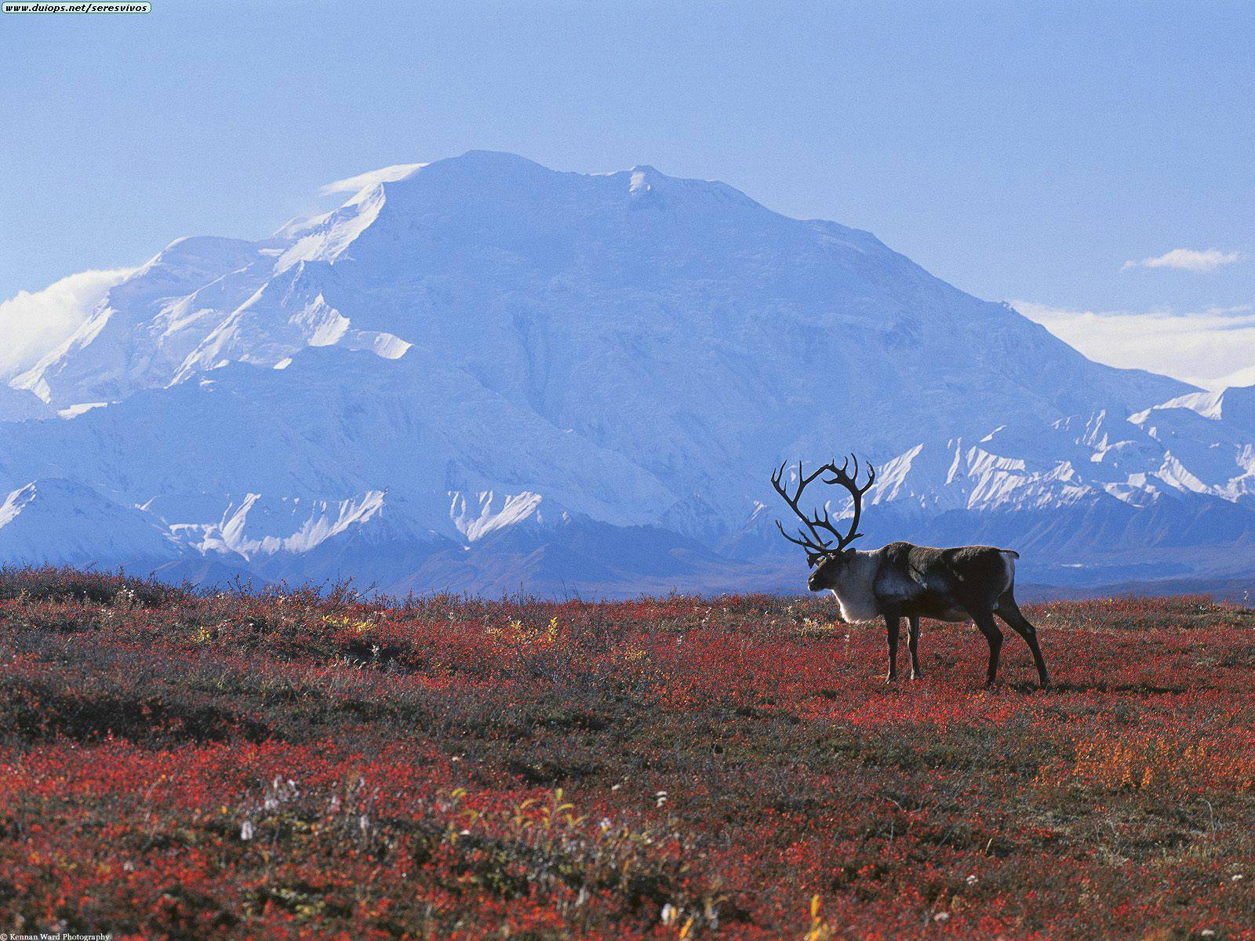
Tundra Biome: The tundra, a virtually treeless biome blanketed by snow in the winter, forms a continuous belt across northern North America, Europe and Asia. Tundralike areas also exist on mountains above the tree line (the highest point at which trees can grow). The tundra is characterized by a low average temperature and a short growing season of about six to eight weeks. Rainfall and snow are scarce, with average precipitation of only about 10 to 12 cm per year (though some tundra areas receive up to 24 cm per year). During the long, cold winters, the ground is completely frozen. During the short summer, only the topmost layer of soil thaws, with the layers below remaining frozen. These lower, unthawed layers are called permafrost. The water from the thawed layer has no place to drain off and there is a low rate of evaporation; therefore, bogs are common in the tundra during the warm season.
Few plants can survive where the temperatures are so low and the ground is frozen for most of the year. Vegetation is primarily limited to lichens, mosses, grasses, sedges and shrubs. The roots of tundra plants grow close to the surface because of the permafrost. Many tundra plants are woody and grow close to the ground — here they find warmer temperatures and are out of the cold, drying winds. The few trees that do grow on the tundra are dwarf willows and birches less than knee high.
The best known of the large tundra animals are probably the caribou. They are well-adapted to the tundra conditions — their thick coats are made of hollow, insulating hairs and their broad feet function as snowshoes in winter. Small herbivores common in the tundra include lemmings, voles, hares and ground squirrels. These animals reproduce prodigiously during the warm season, when there is plenty to eat. Kodiak, grizzly and black bears are among the largest of the tundra omnivores. They eat shoots, berries, insects, fish and the kills of other animals. Coyotes, wolves, cougars and foxes are the main carnivores. The largest herbivores are the Dall and bighorn sheep and the caribou. Some animals, such as the Arctic fox and the Arctic hare, have white fur in the winter and dark fur in the spring. Most of the mammals have a much heavier coat of fur in the winter. Birds found in the tundra year-round include snowy owls and ptarmigans. Many Arctic birds have adapted to the cold by growing feathers on their feet.
During the warm season, a great number of flies and mosquitoes appear in the region. Various types of birds, including sandpipers, ducks and geese, migrate to the tundra during this season. Here, these migratory birds can nest and breed in safety, because of the relative absence of their usual predators. During their breeding season, the birds feed on the growing vegetation and the abundant supply of insects.
\

Coniferous Forest Biome: The coniferous forest is sometimes called the boreal forest or the taiga. In the northern hemisphere, this biome lies south of the tundra. It is dominated by conifers (cone-bearing, needle-leafed, evergreen trees) such as pines, firs, spruces and cedars. The coniferous forest has cold winters during which the ground is covered by deep snow. However, the growing season is longer than that of the tundra — about three months. The summer days are warmer than in the tundra, and the ground thaws completely. Precipitation is greater than in the tundra, averaging between 35 and 75 cm per year. As in the tundra, there are many ponds and bogs.
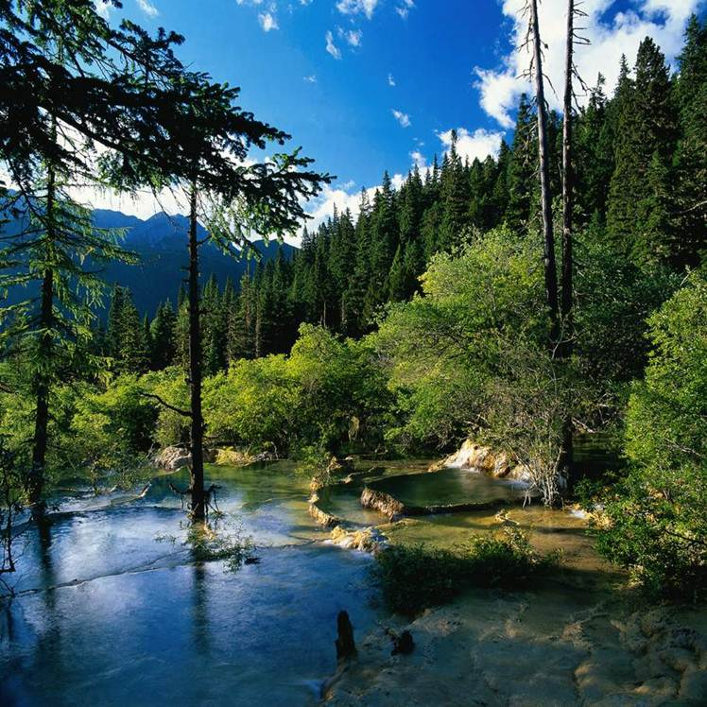
Plants are adapted to survive the long, cold winters, short summers, nutrient-poor soil, and frequent droughts and fires in various ways. The conifers have waxy needles that remain on the trees all winter, allowing them to photosynthesize their food all year. And the shape of their needles and their waxy covering is an adaptation that reduces water loss. Some of the cones are adapted to release their seeds only when singed by fire. The triangular shape of the trees and their branches allows them to shed heavy snow that might break the branches of a deciduous tree. While conifers are the predominant trees of the taiga, some willows and birches are also present. There are also shrubs and herbaceous plants. Ferns and mosses live in the shade beneath the trees but not much else. Shade from the thick conifer branches, together with the poor soil, keeps many plants from growing on the forest floor.
Insects are plentiful during the summer. Insect-eating birds, such as chickadees, woodpeckers, warblers and titmice, are common. Some seed-eating birds have beaks that can open the cones on the trees to eat the seeds. Owls, hawks and eagles are also present, hunting for the small rodents, such as shrews, chipmunks and mice, that are common. Deer, moose, elk, caribou, snowshoe hares, pika, porcupines and squirrels feed on seeds, plants and tree needles. Wolves, cougars, black bears, lynxes, foxes, wolverines and weasels feed on the plant eaters. Many of the animals rely on stored body fat to survive during the cold months, some hibernate, and some migrate to warmer climates in the fall and return in the spring.
The areas south of the coniferous forest have varying amounts of rainfall, so there is no single type of biome that can be said to stretch across these latitudes.

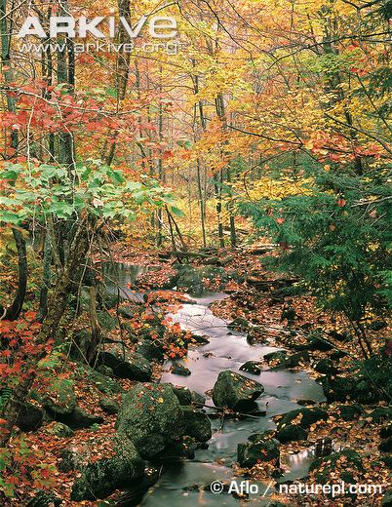
Temperate Deciduous Forest Biome: This biome is found in eastern North America and Europe. It is characterized by the presence of deciduous trees, trees that lose their leaves in fall, also called "hardwoods." In temperature deciduous forest biomes the summers are usually hot and humid, and the winters are cold. Rainfall averages between 75 and 150 cm per year.
The temperate deciduous forest is a region that experiences four distinct seasons, evenly distributed throughout the year. The growing season is about six months long. The moderate rainfall and rich soil of this biome support vast numbers of plant and animal species.
Deciduous trees (including oak, maple, hickory, beech, chestnut, pecan, sycamore, ash, elm, willow, cottonwood and birch) are adapted to their biome by having broad, thin leaves with a large surface area that permits maximum light absorption. They are able to produce and store a huge supply of food during their growing season, which is about six months long. In the autumn, they lose their leaves and spend the winter in an inactive state. A deciduous forest is composed of many layers and provides the greatest number of habitats for animals of all biomes. Unlike in the rain forest, enough light passes through the canopy so that some shorter trees can grow below. Beneath the trees, a layer of shrubs grows. Close to the ground is an herb layer made up of ferns and wildflowers. Finally, there is the forest floor with mosses, lichens and mushrooms.
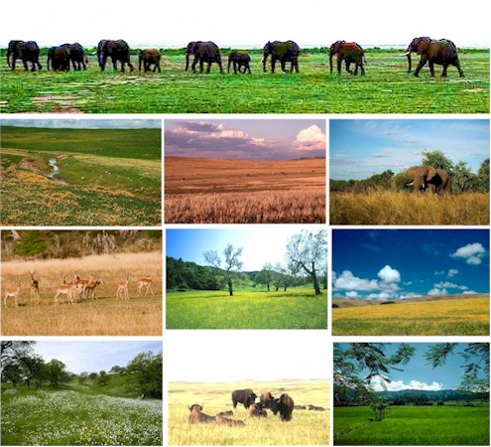
Animals of the deciduous forest include bobcats, white-tailed deer, foxes, raccoons, shrews, black bears, lynxes, moles, skunks, turtles, mice and squirrels. Some animals of the deciduous forest hibernate during the cold winters. Others, like hundreds of bird species (warblers, tanagers and others) spend the warm months in the deciduous forest and migrate to the tropics during the winter. About one-fourth of the bird species that live in the deciduous forest, including the cardinal and bluejay, remain in the forest throughout the winter.

Grassland Biome: Grasslands are found in the interiors of North America, Asia, South America and Africa. Grasslands vary greatly in their temperature ranges, occurring in both temperate and tropical climates where rainfall ranges from 25 to 75 cm per year. Grasslands occur at about the same latitude as deciduous forests but do not receive enough rainfall to support a deciduous forest, and grasses are the dominant form of vegetation. The soil of grasslands is often deep and rich, and these areas have become the most productive farmlands of the earth. (At one time, grasslands covered more than 40 percent of the land in the US; today, most have been cleared for agriculture.) Grasslands are known by various names in different regions of the world — prairie in parts of North America, chaparral in California, steppes in Asia, pampas in South America and veldt in South Africa. Grasslands with a few scattered trees in tropical and subtropical areas, such as those in some parts of Africa, are called savannas.
The natural vegetation of the grasslands includes many species of grasses and wild flowers. Grasslands that receive more rain may have scattered thorny trees like the acacia. In wetter areas, near rivers, the vegetation may be dense and include various shrubs. Grasses can survive trampling and grazing by herbivores, low rainfall and occasional fires, and still grow thickly because the growing part of a grass plant is underground. At the end of each three to six month growing season, the grasses die and decay, making a very rich soil.
Grazing and burrowing species are the dominant forms of animal life, but needless to say, billions of grass-eating insects (like grasshoppers) also live in this biome. Burrowing mammals include ground squirrels, gophers, prairie dogs, and mice. Most of the burrowing animals are primary consumers, but many also eat insects. Empty burrows provide homes for ferrets, badgers, snakes and burrowing owls. Birds — such as prairie chickens, grouse, and meadowlarks — jack rabbits, antelope and bison are also grassland herbivores. Carnivores include the ferrets, badgers, snakes, hawks, coyotes and owls. In the past, wolves were the major predators of the bison herds of the North American grasslands. Of course, wolves and buffalo are rare in the grasslands now.

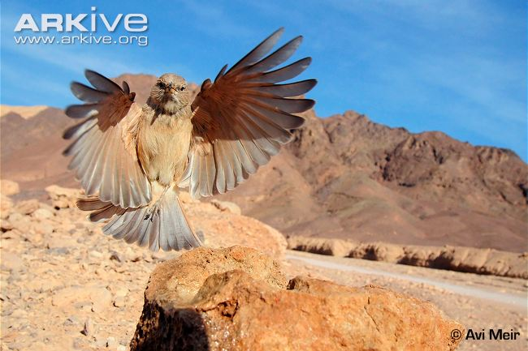
Desert Biome: Deserts occur in regions that are too dry to support grasses. The soil is sandy and poor. Rainfall averages less than 25 cm per year. Temperatures in the desert vary widely in the course of a day. While the days are usually hot, the temperature may drop as much as 30°C at night. Many deserts are not hot year round. In the desert of Idaho and northern Nevada, winter temperatures often plunge below freezing. In a cold desert, like the Gobi Desert in northern China or the Atacama Desert along the west coast of South America, there is still a great difference between daytime and nighttime temperatures. But in a cold desert, daytime temperatures during the winter may be below 0°C (that's below freezing!). Some deserts have almost no vegetation at all, while others have a variety of plants.
Any population of organisms that continues to grow indefinitely will eventually reach a point at which the environment can no longer support it. A lack of food, water, space, or some other basic necessity acts as a limiting factor for every population. A limiting factor is some factor, such as a lack of food, that halts any further growth in a population. The most limiting factor for life in the desert is water. Organisms that live in the desert have evolved special adaptations for the conservation of water.
Most desert plants have widespread, shallow roots that allow them to absorb the maximum amount of water when it is available. Some desert plants absorb water through deep root systems. Many desert plants, such as cacti and succulents, store water in their tissues. The leaves of cacti have evolved into small, sharp spines that help protect the plant against thirsty animals, and photosynthesis is carried on in the green stems. Cacti have a waxy covering on their spines and stems to prevent water loss. Some desert plants live only a short time. They sprout, flower and produce seeds during brief rainy periods that may last for only a few days. The seeds then lie dormant (in an inactive, resting stage) during the long dry spells and sprout during the next rain. Typical plants of the North American deserts include cactus, yucca, mesquite, sagebrush and creosote bush.
Like desert plants, desert animals have a wide variety of adaptations for survival in the harsh environment. Most are nocturnal (active at night) and spend the hot days in burrows in the ground or hidden in any available shade. Many desert rodents can survive with very little drinking water — they get by on the water produced by cellular metabolism and the water present in the plants or seeds they eat. Desert foxes and jackrabbits have long ears that provide a surface area for getting rid of excess body heat. Mule deer, javelina, bighorn sheep, badgers, coyotes, skunks, cougars, snakes, lizards, spiders, insects and birds are other animals typical of the North American deserts.
Owing to poor farming practices like overproducing and overgrazing, the deserts of the world are increasing. These poor agricultural methods leave the topsoil exposed to wind erosion. As a result, dry grasslands become deserts. This process is called desertification.

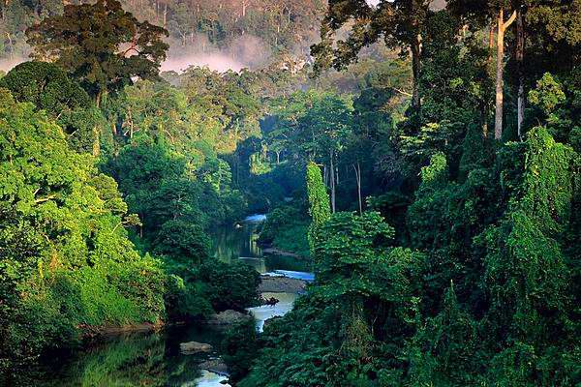
Tropical Rain Forest Biome:

Tropical rain forests, or jungles, are found in areas around the equator, generally 20° north and south of the equator. In these regions, the climate is uniform throughout the year. There is a constant supply of rainfall, which may total between 200 and 400 cm per year or more. Rain occurs nearly every day, and the humidity is high. Temperatures remain constant at about 25°C throughout the year. Since temperature and rainfall changes little year round, the growing season lasts a full twelve months.
Tropical rain forests have distinct layers. Each layer has its own combination of light, temperature and moisture conditions. The tops of the trees form a dense covering called a canopy, which is located between 35 and 50 m above the ground. This is the richest part of the rain forest. It is where most photosynthesis takes place, contains most of the branches, flowers and fruits, and therefore attracts the majority of the wildlife. The trees provide surfaces on which many other plants grow. Woody vines called lianas — some thicker than your leg and more than 50 m long — twist along the tree branches, using the trees to support their rapid growth. Orchids and ferns grow in the branches and in tree hollows. Epiphytes ("air plants" that grow on other plants and do not need soil for their roots) and bromeliads are common. The canopy also provides food and shelter for animals, including vultures, fruit bats, parrots, toucans, spider monkeys, howler monkeys, sloths, tree snakes, poison arrow frogs and insects. The animals that live in the canopy are adapted to life up there, and many never touch the ground.
The tallest trees (some as tall as a twenty-story building, or 70 m high), the ones that break through the canopy, are the emergents. Harpy eagles perch here, searching the canopy for prey. Beneath the canopy little sunlight penetrates, and for this reason the vegetation is relatively sparse. It is estimated that as little as 0.1 percent of the sunlight reaches through the canopy to the forest floor. For this reason, the shrubs and other plants that grow in the understory must be shade-tolerant. The forest floor, the final layer, is dark and humid. In this gloomy environment only shade-tolerant plants can survive. Since the forest floor is dangerous, most animals are arboreal, or tree-dwelling. Those that live on the forest floor include tapirs, jaguars, ocelots, centipedes, termites, agoutis, pheasants, armadillos and boars.
The trees of the rain forest have shallow root systems that allow them to absorb nutrients from the thin layer of wet soil. Many have buttresses (or braces) that extend from the trunks to the ground. Like prop roots, these buttresses help to keep the tree standing upright.
Organic materials decay quickly in this warm, humid environment. Minerals released by decomposition are rapidly taken up again by the plants. Materials not absorbed by the plants are washed away by the frequent rains. Little organic matter is stored in the soil. Most of the nutrients in a tropical rain forest are found within the living organisms. Because of the poor soil, land cleared in this area cannot support crops for more than one or two years.
Tropical rain forests are home to more types of living things than all other terrestrial (land) biomes combined. At present, the habitats of these organisms are disappearing at an alarming rate as the rain forests are destroyed. Many of the plants and animals that inhabit the rain forests produce chemicals that may be useful in fighting some types of diseases. Unfortunately, the world's tropical rain forests are being destroyed by the rapid growth of the human population. If the destruction continues at its present rate, almost all of the tropical rain forests will disappear sometime near the end of this century. Many scientists believe the cutting of the rain forests is partly responsible for the greenhouse effect, a phenomenon caused by increased levels of carbon dioxide in the atmosphere. Excess carbon dioxide causes an increase in the ability of the atmosphere to trap heat, and may cause temperatures around the world to gradually rise.
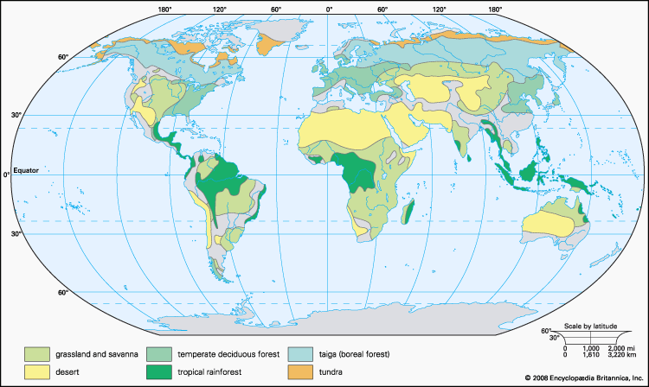

BIBLIOGRAPHY

Mader, Sylvia S. 1988. Inquiry Into Life. 5th edition. Dubuque, Iowa: Wm. C. Brown Publishers.

Maton, Anthea, and Jean Hopkins, Susan Johnson, David LaHart, Charles W. McLaughlin, Maryanna Q. Warner, and Jill D. Wright. 1994. Ecology, Earth's Living Resources. Englewood Cliffs, NJ: Prentice Hall.

Miller, Kenneth R., and Joseph Levine. 1991. Biology. Englewood Cliffs, NJ: Prentice Hall.

Rees, Robin, and Clifford Bishop, eds. 1992. The Way Nature Works. New York: Macmillan Publishing Company.

Schraer, William D., and Herbert J. Stoltze. 1991. Biology, The Study of Life. 4th edition. Englewood Cliffs, NJ: Prentice Hall.

QUESTIONS: Follow your teacher's directions. Your teacher may want you to answer all or only some of these questions. In any event, you can use these questions as a guide in preparing for the biome test. All questions should be answered on a separate sheet using complete sentences.

1. Describe the three main physical components of the biosphere.
2. Define climate. What four interacting factors influence climate? What does climate in turn influence?
3. Define rain shadow. How does a rain shadow affect ecosystems on both sides of a mountain range? [Be able to sketch a diagram that illustrates the rain shadow effect.]
4. Define the term "biome."
5. What are the two MOST important factors that affect the climate of an area?
6. What causes seasonal changes in climate?
7. Why do most tropical rain forest animals live in the trees?
8. In what way does climate determine the type of forest biome in an area?
9. What impact have humans had on the forest biomes?
10. What would happen to the grasslands biome if humans did not interfere and if the rainfall increased over a long period of time? What if rainfall decreased?
11. What wild organisms were replaced when humans came to the US grasslands?
12. What causes the formation of deserts?
13. How have humans helped cause the expansion of desert areas?
14. What physical conditions make the tundra a harsh biome?
15. In what way are conditions high on a mountain in Colorado like those of the tundra of Alaska?
16. Explain why there are grasslands in the same latitudes as forests.
17. What types of adaptations are typical of the plants and animals of the tundra?
18. What types of adaptations are typical of the plants and animals of the coniferous forest?
19. What types of adaptations are typical of the plants and animals of the deciduous forest?
20. What types of adaptations are typical of the plants and animals of the grasslands?
21. What types of adaptations are typical of the plants and animals of the desert?
22. What types of adaptations are typical of the plants and animals of the tropical rain forest?

