Evolution of Life – Take Notes for your starter.
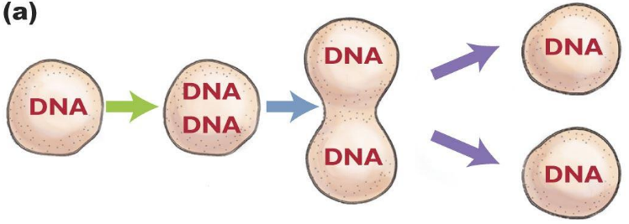
Evolution of first Cells – Molecular Machines Build Houses of Fat – And they want to keep those houses as long as they can, reproduce houses similar to their own, and change over time to improve their chance of surviving and reproducing. The house of fat is a cell surrounded by a plasma membrane composed of lipids (fats). The houses or cells reproduce through division and ensure that each new has all the same components as the one before it and if new cells are created that are better than the previous cells they will survive to pass on their better traits to future generations and the species will evolve to contain those traits.
DNA carries genetic traits. If the combination of traits left to an organism increase its chances of surviving and mating, those traits will be passed on at a higher frequency and thus the species will evolve.

Lipid Membrane surrounding the cell
Lipids = Fats that keep the inside of the cell separate from the outside world. Hence, a house of fat!

Scientists are still working on how chemicals came together to form machines that work together inside cells to promote life. Below is a description of how water played an essential role in this process.
The important chemicals that are needed for all cells survival are described below.
Molecules Essential to Life – are the important chemicals that are needed for all cells survival.
- Carbohydrates (Chains of Simple Sugars) and Simple Sugars – Sugars such as glucose and fructose are used as a fuel to create ATP energy
- Lipids(fats) – create membranes to protect cells and are a source of fuel to create ATP energy
- 4-5 Nucleic Acids – Join together to create DNA and RNA. DNA stores information and controls proteins that work around cells. RNA can store information and work as a cellular machine.
- 20 Amino Acids – Join together in different ways to build large molecular protein machines. These same 20 amino acids are used by all life forms. Proteins do all the work around the cell.
- Inorganic Molecules – Ex. Iron (Fe), Sodium (Na) and Calcium (Ca).
Fe – allows for more oxygen to be inside cells, Ca – strengthens bones, Sodium – important for neurons to work properly

Water is essential to our life forms. The polarity of water is important for many reasons.
- Polar water molecules are attracted to each other and therefore stick to one another. This makes the molecules difficult to break apart which means they will absorb a lot of heat before changing temperature and increasing their kinetic energy. Thus, water is liquid over a wide range of temperatures and has a very high boiling point. This means that chemical reactions can occur within cells without overheating the cell/cells/organism.

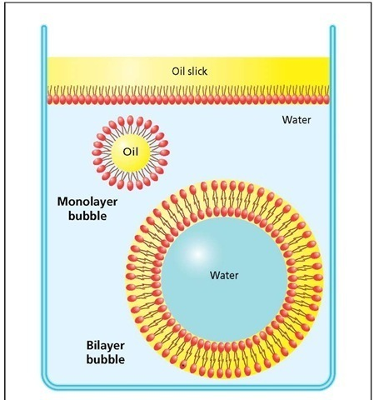
- Ions and other polar molecules such as sugar dissolve easily in water. These molecules are needed for chemical reactions that occur within in cells. These reactions keep the cell/cells/organism alive.

- Ice forms a crystalline structure as a result of water’s polarity and is less dense than liquid water. Thus, ice floats on the ocean’s surface insulating the water below, rather than the ocean freezing from the bottom up. This allows cells to survive in cold waters.

- Hydrophobic Lipids with Hydrophilic Heads – The hydrophobic tails consist of long covalent/non-polar hydrocarbons and are not attracted to water. These tails however have a hydrophilic head that is charged and thus attracted to water. To lower the amount of water the hydrocarbon tails are in contact with, the tails form bubbles or small ring like structures with the heads facing out towards the water. Scientists believe that these were the first rudimentary membranes to encapsulate molecular machines (proto cells). Separating molecules from the outside world provided protection to the molecules within giving them the ability to control their environment by collecting what they want within the membrane and spitting out what they don’t need.

