The Origin of Elements
Directions: As you read through the reading, you will see superscript numbers that correspond to additional information on the last page of the reading for those of you that would like to know more. Following the reading, there will be several options to choose from to complete this homework assignment.
Origin of elements
The big bang created all the Hydrogen (H) in our universe, as well as a few light elements such as Helium (He). These atoms are the parents of all the other elements found in the universe and stars are the wombs that grew them.
67% of the atoms in your body are hydrogen, making 67% of you over 13 billion years old! Those ancient H atoms were around shortly after our universe was created and have remained unchanged ever since. Part of you is as old as time.
Almost every other atom more massive than H and He (meaning they have a nucleus with 3 or more protons) were created in a star almost a billion years later. Hydrogen, Oxygen, Nitrogen and Carbon make up 96% of your body while Calcium and Phosphorous take up 3%, and the rest are trace elements.
A short atomic history lesson
73% of Universe’s visible mass = Hydrogen
He = 25%
Everything else = 2%
13.8 billion years ago is when scientists believe our universe began to expand outward from an infinitesimal point of extreme density and temperature.
After the universe cooled somewhat, elementary particles we call quarks condensed and came together to form nucleons. A nucleon is a proton or neutron and are often found at the center of atoms. (Cooling = Reduction in Kinetic Energy, when the universe cooled the quarks were able to condense without slamming into each other with so much force that they annihilated each other and turned back into electromagnetic energy.)
After further cooling, neutrons and protons began to fuse creating the first Helium nucleons.
Several hundred thousand years of cooling later, the energy dropped low enough to form stable H and He atoms with protons, neutrons and electrons.
A billion years later, clouds of cold H and He gas combined due to the gravitational pull created by their densities. The clouds of energy/matter tell scientists that energy was not distributed evenly throughout the universe by the big bang. If it had been, the atoms would all be equally attracted and repelled by each other and thus never move towards another atom.
As the H and He clouds came together and their density increased, they began to warm, and the kinetic energy of the particles within the star increased.
In this case gravity is applying a force onto the particles in the star, which in turn causes the particles to push outward with an equally strong force. Thus, as the force of gravity increases with the density of the star, the nuclear reactions of the particles increase releasing more radiation: some of which is visible light that we can see at night.¹
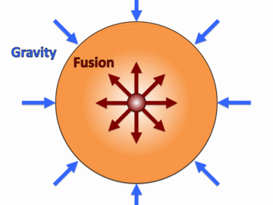
Temperature is a measurement of the thermal kinetic energy of matter. Matter is composed of atoms and all atoms vibrate. An increase in vibration shows an increase in kinetic energy. Water molecules when heated vibrate so violently that they shoot out of the water to zip around in the air as steam.
https://en.wikipedia.org/wiki/File:Thermally_Agitated_Molecule.gif

Warming Up = Increasing the Kinetic Energy/Nuclear Fusion Reactions inside the Star’s Core
After warming to about 100 million Kelvin, stars become Nuclear Reactors and atoms can fuse to form larger nuclei in these protostars. At extremely high temperatures, nuclei separate from their electrons (this is a plasma state of matter) and the nuclei can now interact and fuse to form higher mass elements.² Fusion releases a ton of energy and this radiates outwards from the star combatting the gravitational pull inwards. It also releases visible light that makes a star shine.³
Most of the fusion reactions are creating Helium (He) from 2 Hydrogens. The outward release of energy created from this reaction balances the stars gravitational pull inward and the star is stable at that time.
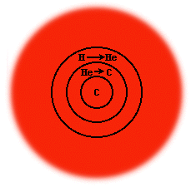
He, once formed, flows to the center of the star, because He is the heavier element in the star between He and H. Thus, gravity will pull the He to the center, or core of the star, and Hydrogen will fill the outer layer of the star. This addition of heavier elements increases the density and therefore the heat (kinetic energy) of the star. This in turn causes a higher rate of Hydrogen fusion reactions.
If the temperature gets high enough, 100,000,000 K, He will fuse to from Carbon (C).⁴
If the star is massive enough, the C atoms (now in the center) fuse to create Neon (Ne).
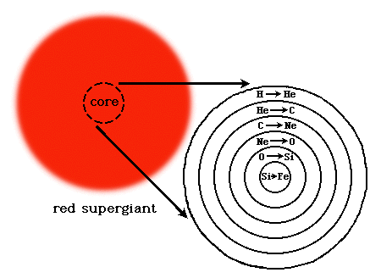
Below, is a list of possible core shells that can be made as the star becomes hotter/more massive.
Ne O (Neon Oxygen)
O Si (Oxygen Silicon)
Si Fe (Silicon Iron)

When the Star Collapses and then Explodes, Its Gone Super Nova
Iron (Fe) further increases the density and therefore heat (kinetic energy) of the star. Fusion of iron is different than all the other fusions that have taken place because Fe nuclei are the most stable of all the atomic nuclei. Therefore, when Fe fuses, energy is not released but absorbed. This creates an imbalance in the star, as there is no longer enough energy radiating outward to balance the gravitational pull inward of the star. The gravity is now stronger than the outward force of the star. Thus, the star begins to shrink and increase in density.⁵ When the core becomes as dense as it can, the outer elements begin to rebound off the core and are thrown outwards. As they fly outwards they collide with other atoms flowing inward. This dramatically increases the kinetic energy of the star and as these nuclei collide larger atoms with more protons in their nuclei are created. The outward force generated by the outer core elements, as the star goes super nova, hurls the matter of the star into the universe. This matter becomes available to the universe and may be used to create planets and species such as ours.
“The nitrogen in our DNA, the calcium in our teeth, the iron in our blood, the carbon in our apple pies were made in the interiors of collapsing stars. We are made of starstuff.” Carl Sagan, Cosmos.
*Did you know? Only 90 of all the known elements are proven to be naturally made. Where do the others come from?
____________Homework on the next page___________

Choose one of the following assignments for your homework grade:

Draw a star before and after a supernova to show us how atoms are made. Include all the atoms involved, and a description of what is happening in both pictures. | Create a story, a picture, a song, a comic strip or some other teacher approved method, to explain how atoms are made inside stars before and after a supernova.  Include all the atoms involved. | Take notes, study, do anything you like to learn the material and take a 5 minute quiz at the beginning of class to test your knowledge of the reading.
Extra Credit:
Add a second element to the homework you chose that illustrates the following concept:

“If you wish to make an apple pie from scratch, you must first invent the universe.” - Carl Sagan, Cosmos

THIS IS EXTRA INFORMATION – just in case you want it
1. The energy produced by nuclear reactions that push back at gravity, are in the form radiation some of which we see as light. In general, the brighter the star, the more massive the star. The more massive the star, the more gravity pulling the stars particles inward. The more energy pulling the stars particles inward, the more kinetic energy produced in the star pushing back outward. Etc…….
2. Fusion of atoms occur when the energy and geometry of a nuclear collision allows for the strong nuclear force to bind them together. Without the extremely high energy, nuclei are like marbles smacking into each other and bouncing off as their protons repel each other when nuclei are too close.
3. The energy released from a star is in the form of radiation. Types of radiation released by a star include; x-ray, gamma-ray, ultraviolet light, visible light, infrared rays, microwaves, and radio waves. Protons and neutrinos are also released and are referred to as solar wind which is a high speed plasma shot into space. Earth’s magnetic field deflects the solar wind and our atmosphere also filters out much of the dangerous radiation released by our solar system’s star, the sun.
4. In case you noticed, He has a nucleus with 2 protons while Carbon has 6. So how do we get to Carbon? Two He atoms join, creating a temporary Be nucleus that quickly joins another He nucleus forming a Carbon nucleus.
5. The Fe nuclei undergo compression and are separated into alpha particles, protons and neutrons. But, the Fe nuclei of the innermost core cannot be infinitely compressed. As the nuclei in the outer cores surrounding the Fe core continue to move inward, they begin to rebound off the compressed core once the core reaches its maximum density. The outer core nuclei bounce off the inner core and are now hurling outwards towards the surrounding outermost layers of Hydrogen nuclei. The hydrogen nuclei are being pulled inwards at the same time as the outer core nuclei are hurling outwards. This dramatically increases the kinetic energy of the star, and as these nuclei collide, larger atoms are created.

The thing about energy becoming particles is not entirely true. Quantum mechanics explains that particles themselves are waves. The energy that forms mass, however, is not a part of the particles themselves. For subatomic particles such as electrons and quarks, their mass is caused by their interaction with the Higgs field. The energy itself is stored in the Higgs field, much like how electric potential energy is stored in electric fields. As for gravity, gravity is not determined by mass. General relativity explains that gravity is the curvature of spacetime caused by the presence of energy, be it in the form of mass, electric potential energy, or electromagnetic radiation. So gravity is not a static force, rather, gravity is the curvature of spacetime caused by the presence of energy.

8down voteaccepted | Energy and matter are not the same. Matter is a type of thing, whereas energy is a property of a thing, like velocity or volume. So your premise is flawed. In particular:  - there's no such thing as "a solid state of energy" - hopefully it makes sense that a property of something does not have states  - energy is not represented by waves, though it is a property of a wave. It's also a property of a particle (which, in quantum field theory, is really just a tightly bunched wave).  Note that mass can be converted to energy, because mass actually is energy. It is one of various types of energy: kinetic energy, potential energy, mass energy, and so on. Different types of energy get converted into each other all the time.

